

**Experiment No.: 05**

**Title:** Running an application in a container, Docker and Docker Hub

# Batch:A4 Roll No.:1914078 Experiment No.:05

**Aim:** To installed Docker, pull and run images form Docker Hub, modify containers to run an application and push it on the Docker Hub

**Resources needed:** Docker Hub Account

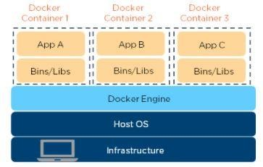

**Theory:**

[**Docker**](https://www.simplilearn.com/tutorials/docker-tutorial/what-is-docker) is an OS-level virtualization software platform that helps users in building and managing applications in the Docker environment with all its library dependencies.

**Docker image** is a read-only, inert template that comes with instructions. In Docker, everything basically revolves around images. An image consists of a collection of files (or layers) that pack together all the necessities—such as dependencies, source code, and libraries—needed to set up a completely functional container environment. Images are stored on a Docker registry, such as the [Docker Hub,](https://hub.docker.com/) or on a local registry.

[**Docker Container**](https://www.simplilearn.com/tutorials/docker-tutorial/what-is-docker-container) is a lightweight software package that includes all the dependencies (frameworks, libraries, etc.) required to execute an application. Running image is the container.

# Procedure:

1. Create Account on Docker Hub
2. Install Docker and explore Docker commands on windows/ VM Linux AWS
3. Pull Nginx web server image and set the port
4. Check working of Nginx container on local host/ live on browser(if it is VM)
5. Change the index file of Nginx container with your own website code [cd/user/share/nginx/html, install Nano editor]
6. Check working of Nginx container on local host with modified index file
7. Push modified Nginx image on Docker Hub

# Results: (Document with screenshots)

1. All steps to Create Docker Hub Account and install Docker
2. 10 Docker commands
3. All commands to pull Nginx, set path, modify, website hosting and push
4. Updated Docker hub repository (before push and after push)
5. Repeat the same on VM or local machine for any other Image of your choice to run an application/program. [Hello world, Ubuntu etc.]

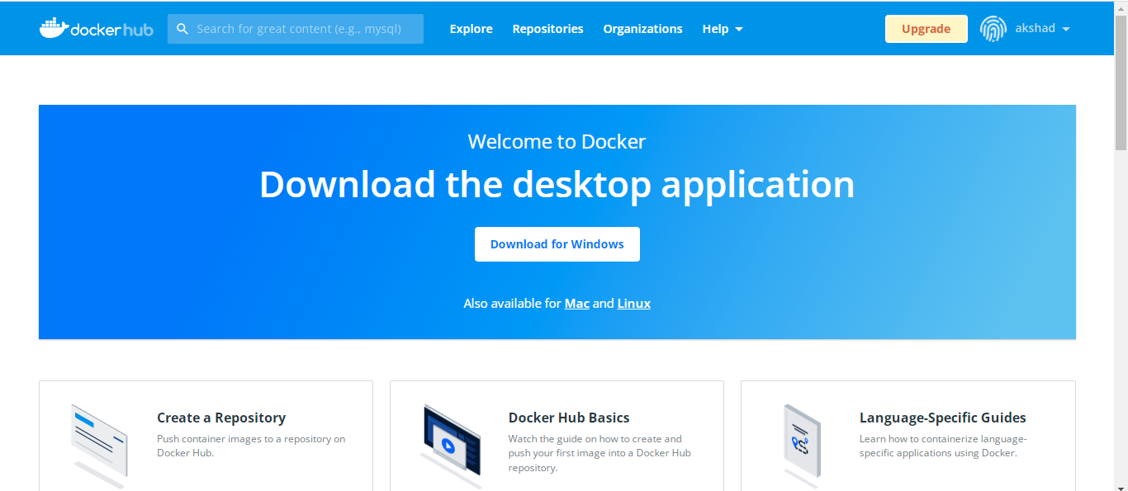

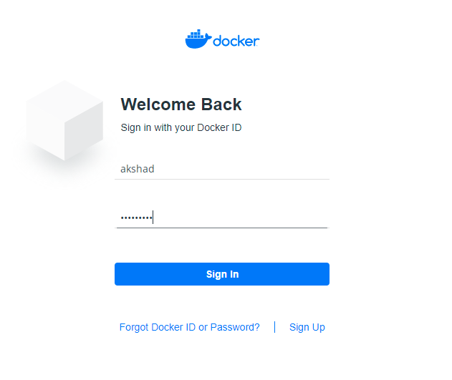

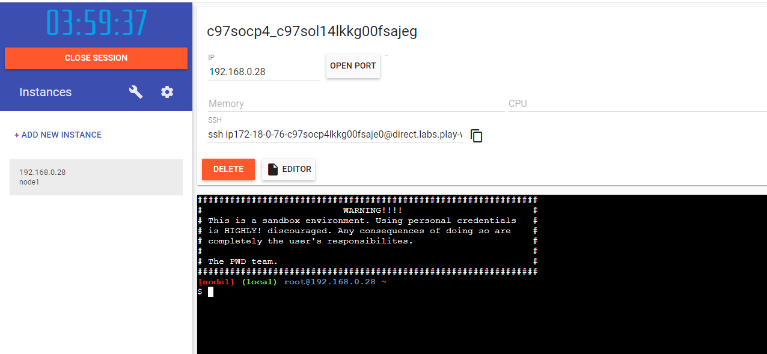

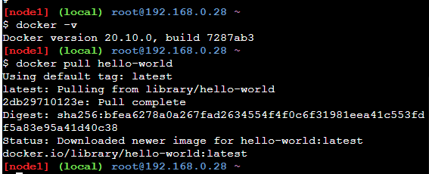

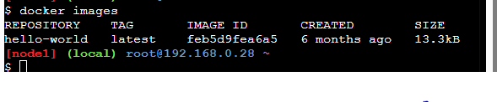

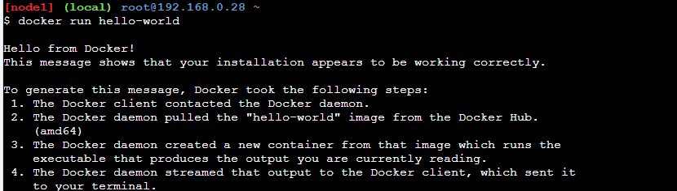

C:\Users\Exam\Pictures\dd\docker7.PNG



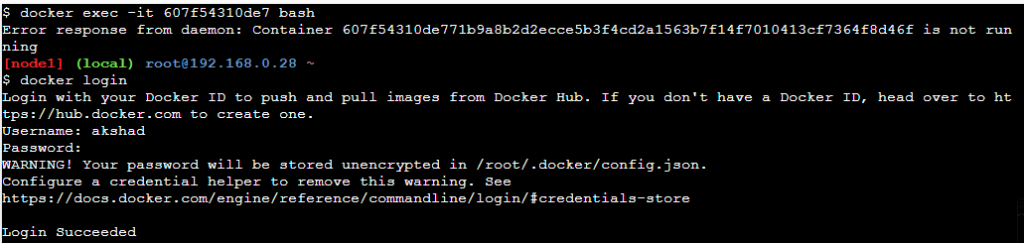

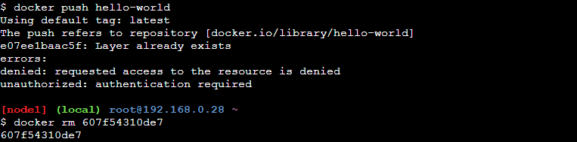

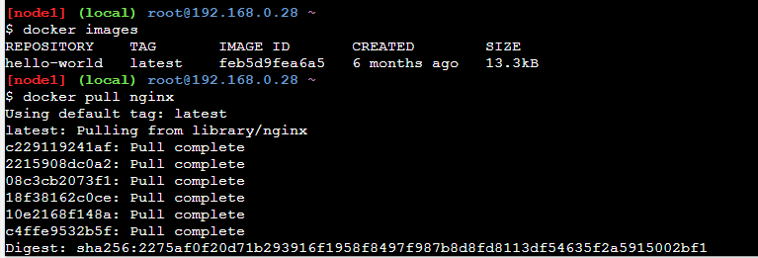

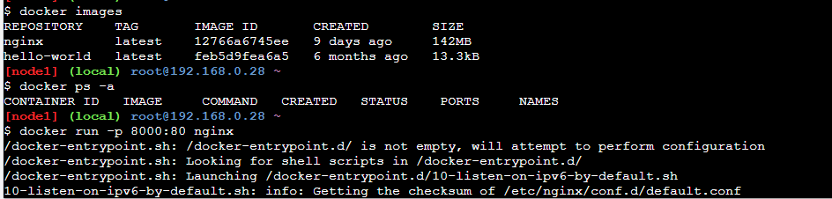

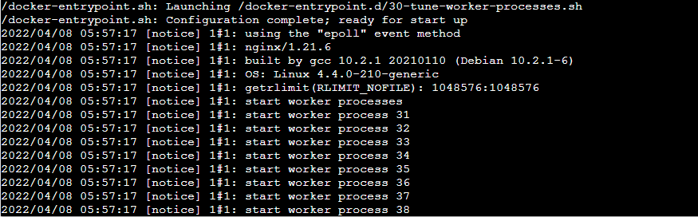

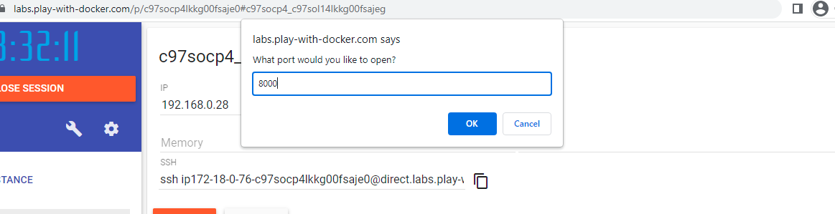

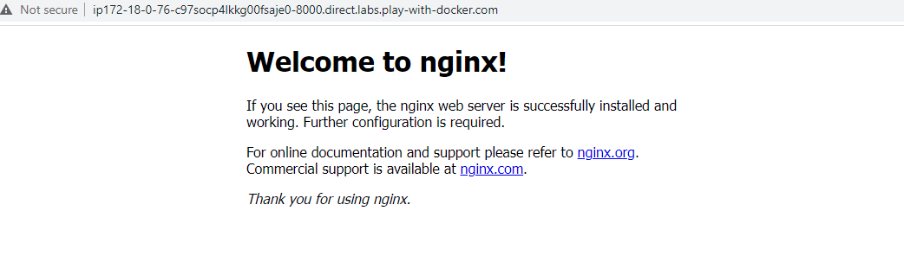

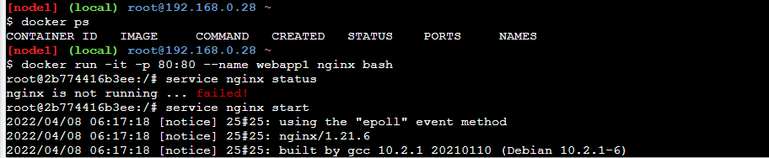

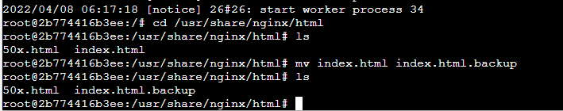

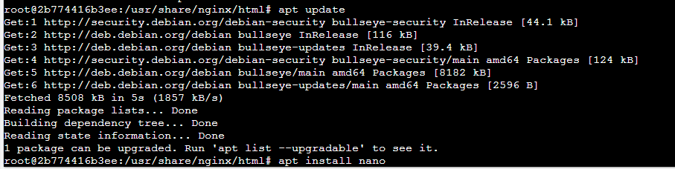

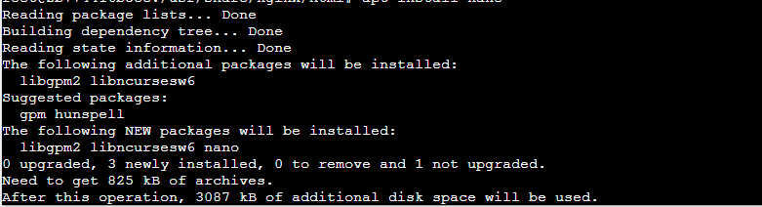

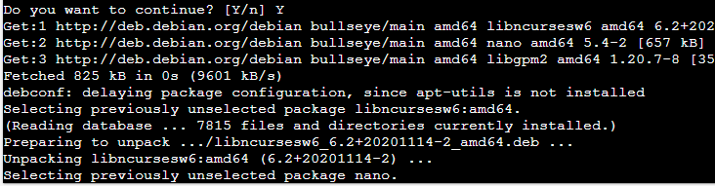

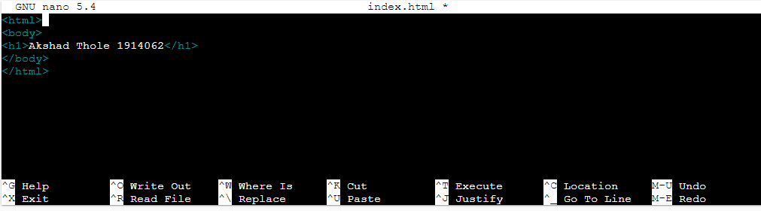

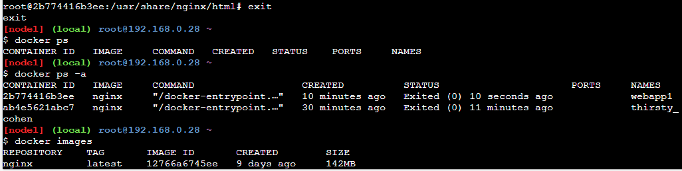

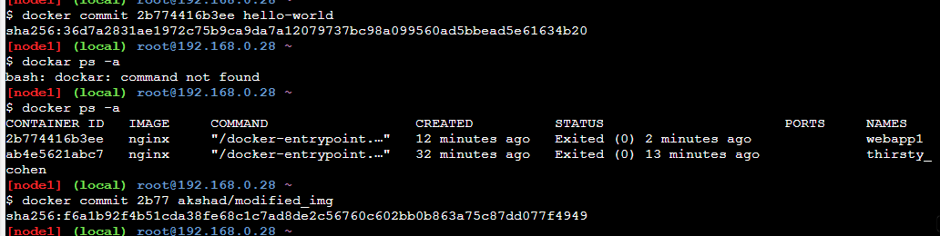

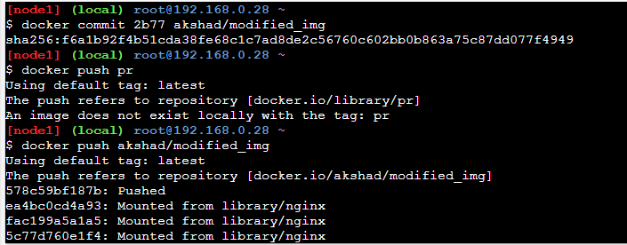

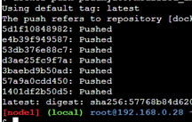

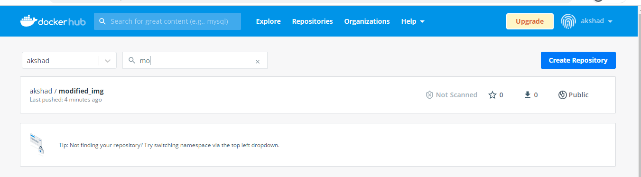

**Questions:**

1. What is Docker file?

Ans: A Dockerfile is **a text document that contains all the commands a user could call on the command line to assemble an image**. Using docker build users can create an automated build that executes several command-line instructions in succession.

When you run the Docker run command and specify WordPress, Docker uses this file to build the image itself. The Dockerfile is essentially the build instructions to build the image.

The advantage of a Dockerfile over just storing the binary image (or a snapshot/template in other virtualization systems) is that the automatic builds will ensure you have the latest version available. This is a good thing from a security perspective, as you want to ensure you’re not installing any vulnerable software.

# Outcomes: Study the Evolution of Cloud Computing and its models

**____________________________________________________________________**

**Conclusion: W**e have learned about the docker and used docker playground and executed some docker commands in it.

**Grade: AA / AB / BB / BC / CC / CD /DD Signature of faculty in-charge with date**

**References:**

**Books/ Journals/ Websites:**

1. htt[ps://www.digit](http://www.digitalocean.com/community/tutorials/how-to-install-and-use-docker-on-)a[locean.com/community/tutorials/how-to-install-and-use-docker-on-](http://www.digitalocean.com/community/tutorials/how-to-install-and-use-docker-on-) ubuntu-18-04
2. htt[ps://www.simplilearn.com/tutorials/docke](http://www.simplilearn.com/tutorials/docker-tutorial/install-docker-on-windows)r[-tutorial/install-docker-on-windows](http://www.simplilearn.com/tutorials/docker-tutorial/install-docker-on-windows)
3. htt[ps://www.simplilearn.com/tutorials/docke](http://www.simplilearn.com/tutorials/docker-tutorial/how-to-install-docker-on-ubuntu)r[-tutorial/how-to-install-docker-on-ubuntu](http://www.simplilearn.com/tutorials/docker-tutorial/how-to-install-docker-on-ubuntu)
4. [https://www.whitesourcesoftware.com/free-developer-tools/blog/docker-images-vs- docker-containers/](https://www.whitesourcesoftware.com/free-developer-tools/blog/docker-images-vs-docker-containers/)
5. Docker Commands Tutorial: <https://www.edureka.co/blog/docker-commands/>
6. Docker Basic Commands | Docker Commands with Examples | Docker Commands Tutorial | Intellipaat: <https://www.youtube.com/watch?v=nXV6qihj5uw>
7. Docker Tutorial 7: nginx server inside container: <https://www.youtube.com/watch?v=rwLfGe0U-zY>
8. htt[ps://www.docker.com/blog/how](http://www.docker.com/blog/how-to-use-the-official-nginx-docker-image/)-[to-use-the-official-nginx-docker-image/](http://www.docker.com/blog/how-to-use-the-official-nginx-docker-image/)